Experiment-4

Code :

import numpy as np

import pandas as pd

# 4.a - Calculate the median

arr = np.array([10, 20, 30, 40, 50])

print("Median:", np.median(arr))

# 4.b - 4x4 array reshaped to 2x8

arr = np.arange(1, 17)

print("Reshaped 2x8 Array:\n", arr.reshape(2, 8))

  # 4.c - Absolute difference between arrays

arr1 = np.array([5, 10, 15])

arr2 = np.array([3, 8, 20])

print("Absolute Difference:\n", np.abs(arr1 - arr2))

  # 4.d - Replace negative values with 0 in 3x3 array

arr = np.random.randint(-10, 10, (3, 3))

arr[arr < 0] = 0

print("Array with Negatives Replaced:\n", arr)

  # 4.e - Cumulative product along columns

arr = np.array([[1, 2], [3, 4], [5, 6]])

print("Cumulative Product Along Columns:\n", np.cumprod(arr, axis=0))

  # 4.f - First 10 Fibonacci numbers using NumPy

fib = np.zeros(10, dtype=int)

fib[1] = 1

for i in range(2, 10):

  fib[i] = fib[i - 1] + fib[i - 2]

  print("Fibonacci Sequence:\n", fib)

Output :

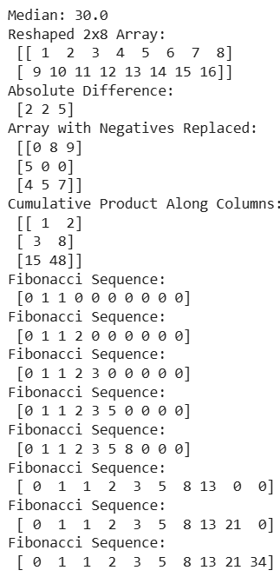

Experiment-5

Code :

# 5.a - Exponential of each element

arr = np.array([1, 2, 3])

print("Exponential of Array:\n", np.exp(arr))

# 5.b - Common elements between two arrays

arr1 = np.array([1, 2, 3, 4])

arr2 = np.array([3, 4, 5, 6])

print("Common Elements:\n", np.intersect1d(arr1, arr2))

# 5.c - 5x5 array and index of max value

arr = np.random.randint(0, 100, (5, 5))

index = np.unravel_index(np.argmax(arr), arr.shape)

print("Array:\n", arr)

print("Index of Max Value:", index)

# 5.d - Pearson correlation coefficient

arr1 = np.array([10, 20, 30])

arr2 = np.array([15, 25, 35])

print("Pearson Correlation Coefficient:", np.corrcoef(arr1, arr2)[0, 1])

# 5.e - Sum of diagonal elements

matrix = np.array([[1, 2], [3, 4]])

print("Sum of Diagonal Elements:", np.trace(matrix))

Output :

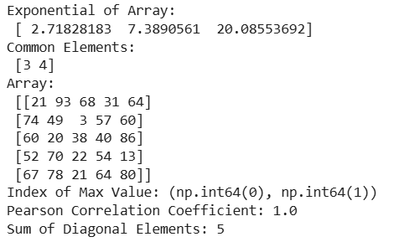

Experiment-6

Code :

# 6.a - Read CSV into DataFrame

import pandas as pd

from google.colab import files

uploaded = files.upload()

df = pd.read_csv("titanic.csv")

print("Titanic CSV Contents:")

# 6.b - Display first 5 rows

df = pd.DataFrame({'A': range(10), 'B': range(10, 20)})

print("First 5 Rows:\n", df.head())

# 6.c - Create DataFrame from dictionary

data = {'Name': ['Alice', 'Bob', 'Charlie'], 'Age': [23, 25, 22]}

df = pd.DataFrame(data)

print("DataFrame from Dictionary:\n", df)

# 6.d - Average of a specific column

df = pd.DataFrame({'Score': [80, 90, 85, 95]})

print("Average of 'Score':", df['Score'].mean())

# 6.e - Max value in a column

df = pd.DataFrame({'Marks': [70, 85, 60, 90]})

print("Max of 'Marks':", df['Marks'].max())

# 6.f - Random DataFrame with 5 rows & 3 columns

data = np.random.rand(5, 3)

df = pd.DataFrame(data, columns=['A', 'B', 'C'])

print("Random DataFrame:\n", df)

Output :

